**Fisheries Data Provided for NCCOS Marine Spatial Planning Analysis**

**Summary of Approach**

We used fishery observer and logbook data for nine fisheries that operate within the two Call Areas in southern Oregon. The observer data was from the Northwest Fisheries Science Center’s (NWFSC) Observer Science Program, and logbook data came from NOAA’s Southwest Fisheries Science Center (SWFSC) Fisheries Resources Division, the Pacific States Marine Fisheries Commision’s Pacific Fisheries Information Network (PacFIN) database, and the Oregon Department of Fish & Wildlife (ODFW). For seven of those fisheries, we matched logbook and observer entries with fish ticket information from the PacFIN database to get inflation-adjusted ex-vessel revenue generated for each fishing event. The time periods of data obtained varied based on availability of data and time constraints that prevented further acquisition of data. See Table 1 for further details of each fishery’s data.

We used these data sets to generate fisheries effort and associated revenue maps at a 2x2-km spatial resolution by spatially overlaying point and line feature geospatial attributes of fisheries monitoring data on a vector-based, polygon grid. Fisheries effort information was summed across all years of data for each grid cell for either hours fished, number or hours of gear deployed or days of fishing. Revenue data were extracted from corresponding PacFIN fish tickets associated with each fishery point or line feature and summed across all years for each grid cell. All fisheries landings revenue data were adjusted for inflation relative to 2020 dollars. Revenue data were always summed for the time period 2011 - 2020 (10 years), whereas effort data were summed across generally longer time periods. Once all of the effort and revenue data were aggregated on the 2x2-km grid, we normalized and ranked the data across grid cells in order to assign appropriate fisheries usage grids that could be fed into the fisheries submodel used by NCCOS (see “Fisheries Activity Spatial Modeling” section below). Confidentiality was tracked for each 2x2-km grid cell by summing the number of unique vessels that fished in the grid cell for each of the nine fisheries. Grid cells that had two or less unique vessels that fished within them over the time period of the data layer for a given fishery, were flagged as confidential for that fishery.

**Summary of Data Shapefiles Provided to NCCOS**

We provided five polygon feature, vector-based shapefiles to NCCOS:

1. Constraint_Scenario_1.shp
2. Constraint_Scenario_2.shp
3. Constraint_Scenario_3.shp
4. Static_data_for_each_scenario.shp
5. Individual_Fisheries.shp

Table 1: List of fisheries NMFS and ODFW identified for inclusion in the model. Nine fisheries were included based on sufficient spatial data, while other fisheries were not included due to limited spatial data or insufficient time to acquire the data.

|  |  |  |  |  |  |  |  |
| --- | --- | --- | --- | --- | --- | --- | --- |
|  | **Federal / State** | **Fishery Management Plan** | **Fishery** | **Metric** | **Indicator** | **Period** | **Source(s) of data** |
| 1 | Federal | [**Pacific Groundfish**](https://www.fisheries.noaa.gov/management-plan/pacific-coast-groundfish-fishery-management-plan) | Groundfish **bottom trawl** (limited entry plus catch shares) ***GFBT*** *in datafiles* | Normalized rank of hours trawled | Cumulative sum of hours trawled | 2002 - 2020 | Logbooks from PacFIN via the observer program database |
| 2 | Federal | [**Pacific Groundfish**](https://www.fisheries.noaa.gov/management-plan/pacific-coast-groundfish-fishery-management-plan) | At-sea **hake** mid-water trawl (mothership and catcher/processor vessels)  ***ASH*** *in datafiles* | Normalized rank of revenue and effort  [a) Inflation-adjusted revenue and b) hours trawled] | Highest normalized value between ranked revenue and effort layers | a) 2011 - 2020  b) 2002 - 2019 | a) NWFSC Observer Program, PacFIN  b) Logbooks from PacFIN via the observer program database |
| 3 | Federal | [**Pacific Groundfish**](https://www.fisheries.noaa.gov/management-plan/pacific-coast-groundfish-fishery-management-plan) | Shoreside **hake** mid-water trawl  ***SSH*** *in datafiles* | Normalized rank of revenue and effort  [a) Inflation-adjusted revenue and b) hours trawled] | Highest normalized value between ranked revenue and effort layers | a) 2011 - 2020  b) 2002 - 2020 | a) NWFSC Observer Program, PacFIN  b) Logbooks from PacFIN via the observer program database for 2011 - 2019 and logbooks for 2002 - 2010 & 2020 from ODFW |
| 4 | Federal | [**Pacific Groundfish**](https://www.fisheries.noaa.gov/management-plan/pacific-coast-groundfish-fishery-management-plan) | Groundfish **fixed gear - pot**  ***GFP*** *in datafiles* | Normalized rank of revenue and effort  [a) Inflation-adjusted revenue and b) gear hours soaked] | Highest normalized value between ranked revenue and effort layers | 2011 - 2020 | ODFW |
| 5 | Federal | [**Pacific Groundfish**](https://www.fisheries.noaa.gov/management-plan/pacific-coast-groundfish-fishery-management-plan) | Groundfish **fixed gear - longline**  ***GFLL*** *in datafiles* | Normalized rank of revenue and effort  [a) Inflation-adjusted revenue and b) gear hours soaked] | Highest normalized value between ranked revenue and effort layers | 2011 - 2020 | ODFW |
| 6 | Federal | [**WC Highly Migratory Species (HMS)**](https://www.fisheries.noaa.gov/management-plan/west-coast-highly-migratory-species) | Commercial **albacore -** troll/hook-and-line  ***ALCO*** *in datafiles* | Normalized rank of revenue and effort  [a) Inflation-adjusted revenue and b) hours fished] | Highest normalized value between ranked revenue and effort layers | a) 2011 - 2020  b) 2005 - 2021 | a) SWFSC, PacFIN  b) SWFSC |
| 7 | Federal | [**WC Highly Migratory Species (HMS)**](https://www.fisheries.noaa.gov/management-plan/west-coast-highly-migratory-species) | Charter **albacore -** troll/hook and line  ***ALCH*** *in datafiles* | Normalized rank of days fished | Cumulative sum of days fished | 2005 - 2021 | SWFSC |
| 8 | State | [**OR Trawl Fishery for Ocean Shrimp**](https://www.dfw.state.or.us/mrp/shellfish/commercial/shrimp/docs/Oregon%20Pink%20Shrimp%20Fishery%20Management%20Plan%20March2018.pdf) | **Pink shrimp** (trawl)  ***PS*** *in datafiles* | Normalized rank of revenue and effort  [a) Inflation-adjusted revenue and b) hours trawled] | Highest normalized value between ranked revenue and effort layers | 2011 - 2020 | ODFW logbook, PacFIN |
| 9 | State | [**OR Dungeness Crab**](https://www.dfw.state.or.us/MRP/management/dungeness.asp) | **Dungeness crab** (pot)  ***CRAB*** *in datafiles* | Normalized rank of revenue and effort  [a) Inflation-adjusted revenue and b) number of pots] | Highest normalized value between ranked revenue and effort layers | a) 2011 - 2020  b) 2007/08 - 2010/11 and 2018/19 - 2019/20 seasons | ODFW logbook, PacFIN |

The first three shapefiles are polygons that delineate the area that NMFS and ODFW are recommending to include in the “Constraints” submodel in order of preference (i.e., Scenario 1 is the most conservative and preferred scenario). The fourth file contains the calculated suitability scores across all nine fisheries using the z-membership function and the geometric average across the nine fisheries. There are five primary feature classes in this fourth shapefile, one for each of the five scenarios described in the “NMFS & ODFW Recommendations and Information: Fisheries” document that Lilah Ise sent on September 30, 2022. The column names are identified by each scenario: “SCEN_1”, “SCEN_2”, “SCEN_3”, “SCEN_4” and “SCEN_5”. These are the corresponding underlying suitability scores that should be used depending on whether constraints are included in the final model. Figure 1 shows how these suitability scores should look if only these constraints or other scenarios without constraints were to be selected by BOEM. The final shapefile contains the “Ranked Relative Importance” values for each individual fishery and the corresponding number of vessels in each grid cell. The names of the features are identified with the abbreviated name of the fishery first followed by “_rank” or “_ves” to note which is the “Ranked Relative Importance” and the “Number of Vessels” data. This shapefile should be used to create maps of the individual fisheries, but should have grid cells with < 3 vessels in each grid removed from the map due to confidentiality requirements.

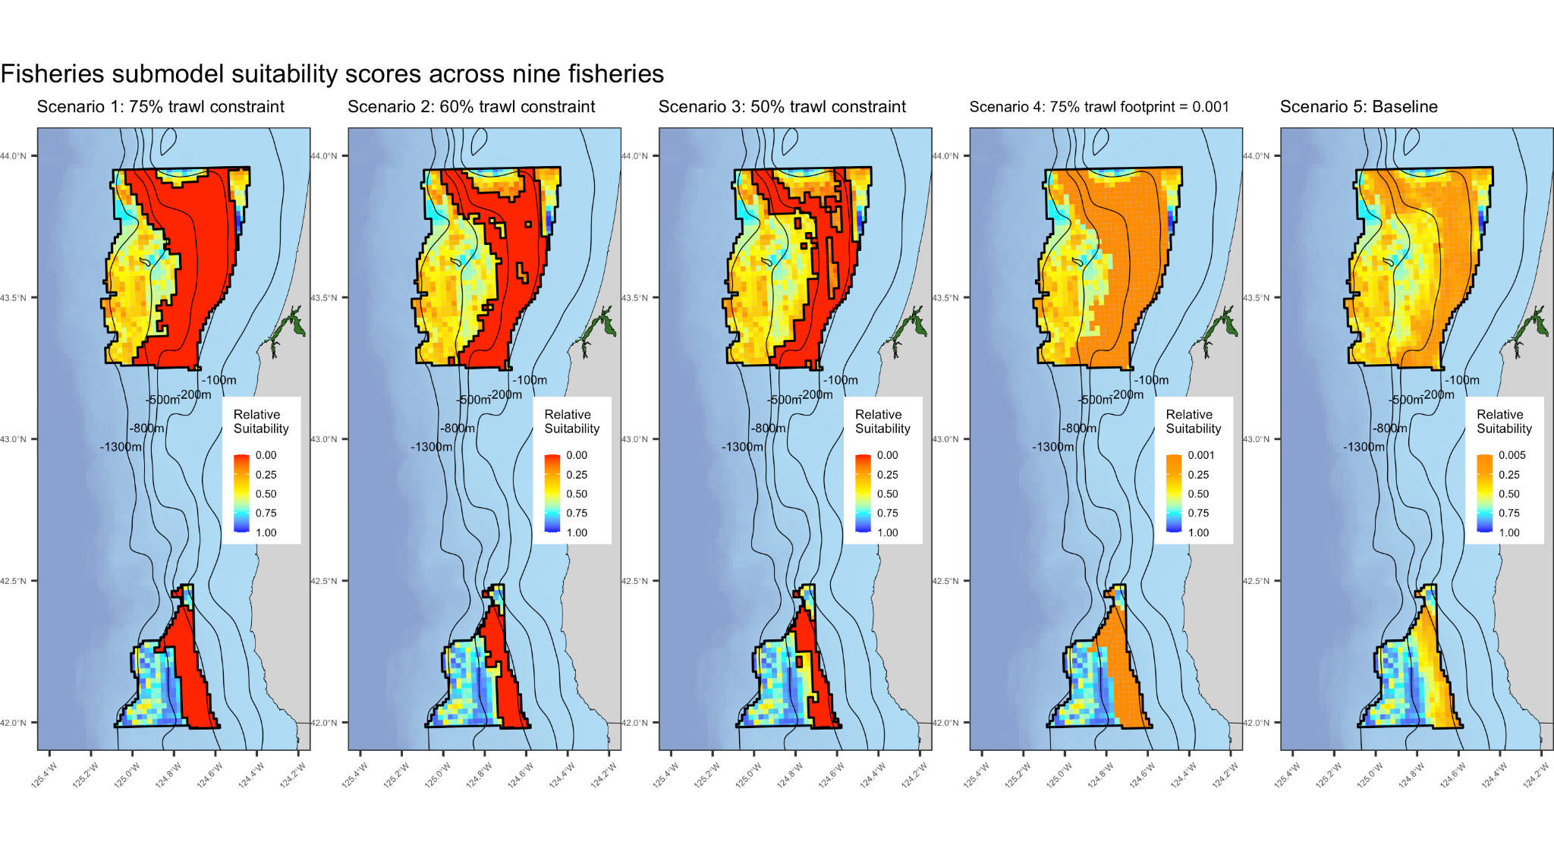

**Figure 1.** Maps of the recommended scenarios from NMFS and ODFW for the fisheries submodel with NCCOS model suitability scores across the nine fisheries. (NMFS-NWFSC).

**Individual Fisheries Data**

Effort data

*Groundfish Bottom Trawl (limited-entry and catch shares)*

We acquired logbook data for 2002 - 2020 for the limited-entry and catch-shares groundfish bottom trawl fishery from PacFIN via the NWFSC’s Observer Science Program. Data were line features in a geodatabase that identified the trawl start and end latitude and longitude coordinates and the duration of each trawling event. The towlines were created using a straight line connecting the start and end points of trawl hauls. We excluded trawling events that intersected land or occurred outside the U.S. exclusive economic zone (EEZ), deeper than 2,000 m or towing greater than five knots (straight line distance divided by tow duration) (Somers et al. 2022). These trawl line features were overlaid and summarized on a 2x2-km resolution grid and clipped to the Oregon Call Area boundaries.

*At-sea Pacific Hake Midwater Trawl*

We acquired logbook data for 2002 - 2019 for the At-sea Pacific Hake midwater trawl fishery from PacFIN via the NWFSC’s Observer Science Program. Data were line features in a geodatabase that identified the trawl start and end latitude and longitude coordinates and the duration of each trawling event. The towlines were created using a straight line connecting the start and end points of trawl hauls. We excluded trawling events that intersected land or occurred outside the U.S. exclusive economic zone (EEZ), deeper than 2,000 m or towing greater than five knots (straight line distance divided by tow duration) (Somers et al. 2022). These line features were overlaid and summarized on a 2x2-km resolution grid and clipped to the Oregon Call Area boundaries.

*Shoreside Pacific Hake Midwater Trawl*

We acquired logbook data for 2011 - 2019 for the Shoreside Pacific Hake midwater trawl fishery from PacFIN via the NWFSC’s Observer Science Program, and logbook data for 2002 - 2010 and 2020 from ODFW. Data from both data sources were line features that identified the trawl start and end latitude and longitude coordinates and the duration of each trawling event. The towlines were created using a straight line connecting the start and end points of trawl hauls. We excluded trawling events that intersected land or occurred outside the U.S. exclusive economic zone (EEZ), deeper than 2,000 m or towing greater than five knots (straight line distance divided by tow duration) (Somers et al. 2022). Data from these two sources were joined and the line features were overlaid and summarized on a 2x2-km resolution grid and clipped to the Oregon Call Area boundaries.

*Groundfish fixed-gear pot*

We acquired logbook data for 2011 - 2020 from ODFW’s Oregon Fixed Gear fishery logbook database. For pot gear fishing events, the data included the number of pots in a “set”, the duration of soak time, a calculated “gear-hours-soaked”, and the start and end latitude and longitude coordinates of each set. We created linestrings using a straight line connecting the start and end points of each set. We excluded fishing events that intersected land, occurred outside the U.S. exclusive economic zone (EEZ), or traversed distances across the entire north-south or east-west directions of the Call Areas. Line features were overlaid and summarized on a 2x2-km resolution grid and clipped to the Oregon Call Area boundaries.

*Groundfish fixed-gear longline*

We acquired logbook data for 2011 - 2020 from ODFW’s Oregon Fixed Gear fishery logbook database. For longline gear fishing events, the data included the number of hooks in a “set”, the duration of soak time, a calculated “gear-hours-soaked”, and the start and end latitude and longitude coordinates of each set. We created linestrings using a straight line connecting the start and end points of each set. We excluded fishing events that intersected land, occurred outside the U.S. exclusive economic zone (EEZ), or traversed distances across the entire north-south or east-west directions of the Call Areas. Line features were overlaid and summarized on a 2x2-km resolution grid and clipped to the Oregon Call Area boundaries.

*Commercial Albacore Tuna Troll and Hook-and-line*

We acquired logbook data for 2005 - 2021 for the commercial albacore tuna fishery from the highly migratory species (HMS) logbook database across the entire EEZ from the SWFSC. Data were point features in a .csv file, reported at a 1 arc-minute spatial resolution that contained a single latitude and longitude for the location of fishing for each date. In addition, the number of hours fished is an optional piece of information reported for some fishing events. In order to best represent the magnitude of spatial effort across these Call Areas by this fishery using as much of the logbook data as possible, we adjusted the “hours fished” information if it was not reported. The adjusted value was calculated based on the most specific information available across the entire dataset. We used the following four scenarios to calculate adjusted hours-fished for missing information, in this order of specificity:

1. Adj_hours_fished = Average of reported hours fished of other fishing events for the same vessel in the same grid cell during the same year;
2. Adj_hours_fished = Average of reported hours fished of other fishing events for the same vessel during the same year;
3. Adj_hours_fished = Average of reported hours fished of other fishing events for the same vessel;
4. Adj_hours_fished = Average of reported hours fished of other fishing events for the same grid cell

Across all years, there were duplicate rows (111) in the file, which were deleted using the following attributes and left 151,176 point features when completed:

* FISHERY
* VESSEL_NAM
* REG_NUMBER
* TRIP_ID
* START_DATE
* END_DATE
* FISH_DATE
* LATITUDE
* LONGITUDE
* HRS_FISHED

Grid and spatial problems:

There were anomalously high incidents of points reported at 5- and 10-arc-minute intervals. This bias in geolocation reporting by fishermen was determined by overlaying points on a 1 arc-minute resolution grid, and an increased frequency of points falling on grid cells at 5- and 10-arc-minute intervals were clearly evident. We also generated frequency distributions of the decimal portion (e.g., decimal portion of 47.25 is 0.25) of all ~90k geocoordinates (2011 - 2020), and there were 2.3 times as many points with 5 arc-minute spacing and 4.8 times as many at 10 arc-minute spacing than you would expect from a random distribution of point locations. Based on this strong spatial bias in the data, we presumed that many fishermen report their location to only 5- or 10-arc-minutes resolution, so the albacore point features were overlaid and summarized on a 10 arc-minute resolution grid and then resampled to the higher resolution 2x2-km grid. Finally, we clipped these data to the Oregon Call Area boundaries.

*Charter Albacore Tuna*

We acquired logbook data for 2005 - 2021 for the charter albacore tuna fishery from the highly migratory species (HMS) logbook database across the entire EEZ from the SWFSC. Data were point features in a .csv file, reported at a 1 arc-minute spatial resolution that contained a single latitude and longitude for the location of fishing for each date. Similar to the commercial albacore tuna logbook data, the number of hours fished is an optional piece of information reported in this logbook database. However, for the charter albacore logbook data, there were too few fishing events that reported “hours fished”, so we used “cumulative number of days fished” as the primary metric to summarize fishing effort for this fishery.

Grid and spatial problems

Similar to the commercial albacore data, the spatial resolution of the coordinates reported in the logbooks appear to be at a coarser spatial resolution; thus, we overlaid and summarized on a 10 arc-minute resolution grid, resampled to the higher resolution 2x2-km grid and clipped to the Oregon Call Area boundaries. Refer to “Grid and spatial problems” in the “Commercial Albacore Tuna” methods for the Effort calculations above for details.

*Ocean Pink Shrimp*

We used the 13 June 2022 version of the Pink Shrimp Logbook data received from ODFW. Data were point features in an Excel spreadsheet, reported with the geocoordinates for each point location. Data were filtered for the window of years 2011 - 2020. Logbook points that overlapped with land were excluded from the analyses. ODFW recognizes that the most appropriate unit of effort for this fishery is the number of hours fished for each haul. We used the EXPANDHRS attribute calculated by ODFW, which accounts for the logbook subsampling that occurs for entry into their databases and extrapolates to 100% of the pink shrimp effort. With total hours of effort assigned to each pink shrimp haul, the points were overlaid on the 2x2-km grid and the cumulative hours fished from 2011 - 2020 was calculated for each grid cell.

*Dungeness Crab*

We acquired logbook data for the Oregon Commercial Dungeness Crab fishery for fishing seasons with 100% data entry, which included 2007-2008 through 2010-2011, and 2018-2019 through 2019-2020 seasons. ODFW recognizes that the most appropriate unit of effort for this fishery is the “number of pots” set in each string. For each string of pots, we created linestrings using a straight line connecting the start and end points of each string. We excluded fishing events that intersected land, occurred outside the U.S. exclusive economic zone (EEZ), or traversed distances across the entire north-south or east-west directions of the Call Areas. Line features were overlaid and summarized on a 2x2-km resolution grid and clipped to the Oregon Call Area boundaries.

Revenue data

*PacFIN Fish Ticket Data*

We used the 4 Jan 2022 version of the Pacific Fisheries Information Network fish ticket database. We used the “FTID” attribute for joining to fisheries monitoring data that lists a fish ticket ID for each trawl tow of pot set. All revenue data extracted from fish tickets were adjusted for inflation relative to 2020 USD by PacFIN, presumably using the gross domestic product implicit price deflator calculated from NIPA Tables 1.1.5 and 1.1.6. (https://apps.bea.gov/iTable/iTable.cfm).

*Groundfish bottom trawl*

We did not have adequate time to obtain, match and process fish ticket data with corresponding logbook data for the groundfish bottom trawl fishery. If there is an opportunity to include this in the modeling effort at a later date, we would be interested in providing revenue data to complement the effort data.

*At-sea and Shoreside Pacific Hake Midwater Trawl*

We used the 30 Nov 2021 version of observer data obtained from the NWFSC’s Observer Science Program. Data were line features in an R data frame, reported with the geocoordinates for the start and end of each trawl towline. The towlines were created using a straight line connecting the start and end points of towlines. Data were filtered for the window of years 2011 - 2020. Per the recommendations of Somers et al. (2022), “We excluded hauls or sets that intersected land or occurred outside the U.S. exclusive economic zone (EEZ) for all sectors.” For the at-sea hake, we calculated the total ex-vessel revenue for each towline by multiplying the PWHT_KG attribute by the corresponding mean weekly ex-vessel price per kg in the PacFIN database. For the shoreside hake, we multiplied the PWHT_MT attribute by the corresponding mean weekly ex-vessel price per MT in the PacFIN database. We then spatially intersected the at-sea and shoreside hake towlines with the 2x2-km grid and calculated length proportional, cumulative revenue of hake caught by each fleet in each grid cell.

*Groundfish fixed-gear pot*

We acquired logbook data for 2011 - 2020 from ODFW’s Oregon Fixed Gear fishery logbook database. For pot gear fishing events, the data included the total trip revenue and the start and end latitude and longitude coordinates of each set. We created linestrings using a straight line connecting the start and end points of each set. We excluded fishing events that intersected land, occurred outside the U.S. exclusive economic zone (EEZ), or traversed distances across the entire north-south or east-west directions of the Call Areas. Line features were overlaid and summarized on a 2x2-km resolution grid and clipped to the Oregon Call Area boundaries.

*Groundfish fixed-gear longline*

We acquired logbook data for 2011 - 2020 from ODFW’s Oregon Fixed Gear fishery logbook database. For longline gear fishing events, the data included total trip revenue and the start and end latitude and longitude coordinates of each set. We created linestrings using a straight line connecting the start and end points of each set. We excluded fishing events that intersected land, occurred outside the U.S. exclusive economic zone (EEZ), or traversed distances across the entire north-south or east-west directions of the Call Areas. Line features were overlaid and summarized on a 2x2-km resolution grid and clipped to the Oregon Call Area boundaries.

*Commercial Albacore Tuna*

We acquired commercial albacore logbook data for 2005 - 2021 from the highly migratory species (HMS) logbook database across the entire EEZ from the SWFSC’s Fisheries Resources Division. Data were point features in a .csv file, reported at a 1 arc-minute spatial resolution. Data were filtered for the window of years 2011 - 2020.

There were duplicate rows (46) in the file, which were deleted for 2011 - 2020 using the following attributes and left 89,853 point features when completed:

* FISHERY
* VESSEL_NAM
* REG_NUMBER
* TRIP_ID
* START_DATE
* END_DATE
* FISH_DATE
* LATITUDE
* LONGITUDE
* HRS_FISHED

Grid and spatial problems

Refer to “Grid and spatial problems” in the “Commercial Albacore Tuna” methods for the Effort calculations above for details.

We calculated the ex-vessel revenue for each albacore logbook entry by linking the TRIP_ID attribute with the matching TRIP_ID attribute in the PacFIN fish ticket database. Since there were multiple occurrences of the same TRIP_ID attribute value in the logbook data, i.e., multiple trips had the same TRIP_ID value, we calculated the value of each logbook entry by dividing the corresponding TRIP_ID ex-vessel value listed in the PacFIN database by number of albacore logbook entries with that TRIP_ID. With total adjusted for inflation ex-vessel revenue assigned to each albacore logbook entry, the points were overlaid on the 10 arc-minute resolution grid and the cumulative revenue from 2011 - 2020 was calculated. The 10 arc-minute resolution ex-vessel values were then resampled to the higher resolution 2x2-km grid. Finally, we clipped these data to the Oregon Call Area boundaries.

*Charter Albacore Tuna*

We did not have the necessary time to explore whether revenue data is available and could be matched to the fishing events for this fishery.

*Ocean Pink Shrimp*

We used the 13 June 2022 version of the Pink Shrimp Logbook data provided by ODFW. Data were point features in an Excel spreadsheet, reported with the geocoordinates for each point location. Data were filtered for the window of years 2011 - 2020. Logbook points that overlapped with land were excluded from the analyses. The ex-vessel value of each logbook point was calculated by linking the TICKNUM attribute in the logbook entry with the corresponding FTID attribute in the PacFIN fish tickets database. ODFW provided the estimated pounds landed in each haul, which was corrected using the expansion factor in the EXPFACT attribute. As was the case for the Dungeness crab logbook data, ODFW does not always enter all of the logbook records into their databases, so they use an expansion calculation that corrects for the stratified random sampling design that they use for logbook record conversion to their databases. Since any given pink shrimp haul TICKNUM may have multiple occurrences in the PacFIN database, the mean ex-vessel price per pound was calculated from the PacFIN data and then multiplied by the expanded and corrected weight listed in the corresponding logbook entry. With total adjusted for inflation ex-vessel revenue assigned to each pink shrimp haul, the points were overlaid on the 2x2-km grid and the cumulative revenue from 2011 - 2020 was calculated.

*Dungeness Crab*

We used the 7 January 2022 version of the ODFW Dungeness Crab Logbook data provided by ODFW. Data were line features in an Excel spreadsheet, reported with the geocoordinates for the start and end of each string of pots. For each string of pots, we created linestrings using a straight line connecting the start and end points of each string. Data were filtered for the 10-year window of crab seasons running between 2010/11 to 2019/20. Linestrings that overlapped with land or had a “SpatialFlag” attribute value of “True” were excluded from the analyses. ODFW assigned the ex-vessel value of each linestring line in the “AdjValue” attribute, and these values were adjusted for inflation for each calendar year using the same annual adjustment values used in the PacFIN fish tickets. We spatially intersected the linestring with the 2x2-km grid and calculated length proportional, cumulative revenue of Dungeness crab caught in each grid cell. ODFW subsampled 30% of logbook entries provided by fishers for the 2011/12 to 2017/18 crab seasons and there isn’t 100% reporting on the logbooks provided by fishers, so data were expanded to 100% of the total value landed in Oregon ports for each year. We calculated the expansion assuming that the linestring with logbook data were a random sample of the total fishing activity. We made the expansion calculations on each 2x2-km grid cell by dividing the total revenue associated with the grid cell for each year by the corresponding proportion of revenue that was reported at all Oregon ports in the corresponding year. In other words, across all 2x2-km grid cells with logbook data, we calculated the cumulative total annual revenue generated each year and compared with the cumulative annual value landed at all Oregon ports. This annual fraction or proportion was used as the denominator for the grid cell by grid cell expansion done for each year. Finally, we selected out only the 2x2-km grid cells that overlapped with the two call areas, and those grid cells were processed in the Fisheries Activity Spatial Modeling below.

**Relative Importance of Space within the Oregon Call Areas to each Fishery**

*Data Distribution Concerns*

Preliminary examination of how fisheries effort and revenue data would be represented in the NCCOS modeling approach suggested that the raw data were highly-skewed and resulted in relative suitability scores that did not adequately represent the space fisheries needed in the ocean to safely and functionally operate. For example, the data showed that there were a few grid cells within the Oregon Call Areas that were outliers with extremely high effort and/or revenue values, while the majority of the grid cells where fisheries operated had relatively low effort or revenue values in comparison. When these skewed distributions were used in the modeling framework, very few grid cells (< ~20 out of 1306 total 2x2-km grid cells) had final suitability scores < 0.50, which does not adequately represent the spatial extent of important areas for these fisheries.

In order to remedy the problems associated with the skewed distribution of the raw data, we explored two types of data transformations: log and rank transformations. For each data set, we log-transformed and ranked the raw data. For ranking, the grid cell with the highest effort or revenue value received the highest rank value. For example, the groundfish bottom trawl fishery operated in 1264 out of the 1306 grid cells within the Call Areas from 2002 to 2020, so the grid cell with the highest effort value was assigned a rank value of 1264 and subsequent cells were ranked in descending order. These exploratory analyses suggested that ranking each grid cell from highest to lowest effort or revenue value created a more normal distribution (compared to the raw data) of final suitability scores and also provided the necessary contrast between areas that were most and least important to each fishery. The log-transformed data resulted in a more normal distribution as well, but tended to have more grid cells assigned suitability scores that were in the middle of the suitability score range and did not result in the contrast that is important for marine spatial planning efforts. Thus, we selected the ranked transformation of the raw effort and revenue data.

*Relative Importance: Combining Effort and Revenue Data*

For seven of the nine fisheries, we had both effort and revenue information. Each of these metrics provided valuable information about where fisheries occurred and which areas of the ocean were most important to each fishery. Most of the fisheries showed relatively high correlations between effort and revenue data (Figure 2). However, there were grid cells that showed relatively higher than expected revenue values when compared to the effort data, and vice versa, some grid cells had higher effort values than expected when compared to the 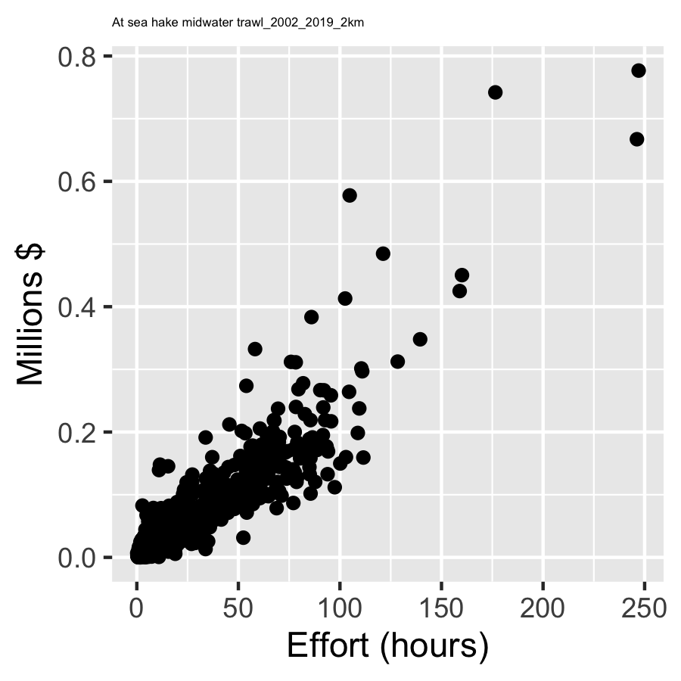

**Figure 2**. Correlation between fishing effort (hours) and revenue (millions of $US) for the At-sea Pacific hake fishery for grid cells within the Oregon Call Areas.

revenue data. It is important to capture these characteristics because fishing vessels operate in different locations for many reasons that may not be directly related to their ability to catch the most profitable species each and every time they fish. For example, a vessel may operate in an area that is either free from other boats (i.e., no overlap in gear or paths) or that have other boats in the vicinity (e.g., safety in numbers); areas that have better bottom habitats or are easier to trawl or set in; areas where the weather is better; or areas that have an abundance of species that a processor is in need of. Thus, we combined the ranked effort and revenue data in the following way:

1. We normalized the ranked effort and revenue data independently between values of 0 and 1 by subtracting the minimum value of the dataset from each value and dividing by the difference between the minimum and maximum values of the dataset.
2. For each grid cell, we then selected the highest normalized value between the effort and revenue normalized values. We called these values “Relative Importance” scores and these are the values provided to NCCOS in the “Individual_Fisheries.shp” shapefile.

**Final Submodel Suitability Scoring**

The Relative Importance scores for each fishery were then used as the input for the NCCOS modeling approach. We used the z-membership function identified in Equation 2.2 in the Aquaculture Opportunity Areas Atlas (Riley et al. 2021) to transform the Relative Importance scores. Any grid cell that did not have any fishing activity captured across these nine fisheries was given a z-membership score of 1. We then calculated the geometric mean of each grid cell using the z-membership scores across all nine fisheries. This resulted in the final Fisheries Submodel Suitability Scores for each grid cell. These suitability scores are the values provided to NCCOS in the “Static_data_for_each_scenario.shp” shapefile.

**Literature Cited**

Riley KL, Wickliffe LC, Jossart JA, MacKay JK, Randall AL, Bath GE, Balling MB, Jensen BM, Morris JA Jr. 2021. An Aquaculture Opportunity Area Atlas for the U.S. Gulf of Mexico. NOAA Technical Memorandum NOS NCCOS 299. 545 p. DOI:10.25923/8cb3-3r66

Somers, KA, CE Whitmire, E Steiner, JE Jannot, KE Richerson, VJ Tuttle & JT McVeigh (2022) Fishing Effort in the 2002-19 U.S. Pacific Coast Groundfish Fisheries. Technical Memorandum, Seattle, WA. USA, p. URL<https://repository.library.noaa.gov/view/noaa/35781>